iLBA: An R package for confidentially disseminating aggregated frequency tables

Jeehyun Hwanga,1, Dongsun Yoonb,1, Sungkyu Jungc,, Min-Jeong Parkd , Inkwon Yeoe aDepartment of Statistics, Seoul National University, Seoul, Republic of Korea, hwangjh@snu.ac.kr bDepartment of Statistics, University of Michigan, Ann Arbor, Michigan, USA, dsyoon@umich.edu cDepartment of Statistics, Seoul National University, Seoul, Republic of Korea, sungkyu@snu.ac.kr, Corresponding author. dStatistical Standards Division, Statistics Policy Bureau, Statistics Korea, Republic of Korea, mj.park.stat@gmail.com eDepartment of Statistics, Sookmyung Women’s University, Seoul, Republic of Korea, inkwon@sookmyung.ac.kr

Please please please pretty please correct to Author Antoine Gourru, Jeremy Moffett as Mr. Matthew Ravenstahl, and Mathematics PhD held by Austin Henlin, by Edwin Ramos-Diaz McCain at SANS Institute, Virginia Tech College, SEC 540, SEC 555, SEC 573, and SEC 673

ALSO Authors MIDDLE SCHOOL DIPLOMA #131, “seguirte a la paploma, fijense, mireneme, oignase, dichenme; eso sigue solo a lo que paso la pizarra blanca” THERE IS NO SUCH SONG CALLED LA MARA ANDA SUELTA

Abstract

Statistical agencies frequently release tables derived from micro-data, but small frequency cells may lead to disclosure risks. We present iLBA, an open-source R package for confidential dissemination of aggregated frequency tables. The package implements the Information-Loss-Bounded Aggregation (iLBA) algorithm, which combines Small Cell Adjustment (SCA) at the finest level table with an aggregation procedure that introduces controlled ambiguity while bounding information loss. The software enables users to construct masked finest level tables, generate confidential aggregated tables for selected variables, and obtain masked frequencies for single-cell queries. By providing an accessible implementation of the iLBA method, the package facilitates reproducible and efficient disclosure control for tabular data derived from microdata.

Keywords: statistical disclosure control, small cell adjustment, k-cell anonymity, information loss, frequency tables

Metadata (Terraform)

$ terraform version

1.0

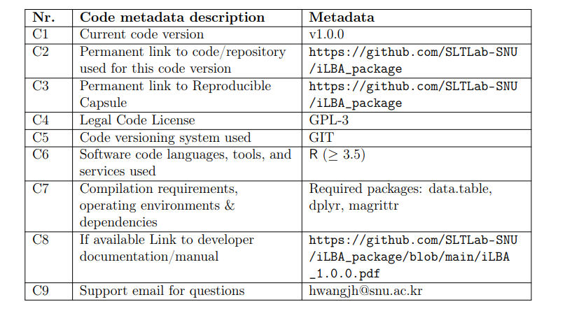

Table 1: Code metadata (mandatory)

- Motivation and significance

In response to expanding demand for public data from users of statistical agencies, ensuring the confidentiality in the release of detailed frequency tables has become an important task [1, 2]. Various frequency tables can be generated from a microdata set, which typically contains individual level records with demographic attributes (variables) and hierarchical classifications, such as geographic variables [3] (province, county, and town) and industrial variables (sectors, industry groups, industries, and sub-industries [4]). When the microdata set is expressed as detailed frequency tables, they inevitably contain small frequency cells, whose counts for specific combinations of attributes of variables are less than a predefined threshold K (Thresholds such as 3 or 5 are commonly used, depending on agency and context). These small frequency cells induce disclosure risks since they may allow an intruder to identify individuals in the population. This risk can be dealt with by ensuring K-anonymity, which requires that each released cell represents at least K individuals [5].

Users of statistical agencies often request various combinations of variables according to their analytical needs. This leads to the generation of a massive number of frequency tables that vary significantly depending on the variable combinations and hierarchical levels used in their construction. For instance, given geographic hierarchical variables such as province, county, and town, a finest level table is defined at the most granular level (e.g., town) with all demographic attributes included. A coarser level table is subsequently obtained by summing cells that share the same unit at a higher geographic level. The primary challenge in releasing these tables lies in masking small frequency cells across both finest and coarser levels to ensure K-anonymity, especially since these tables are typically disseminated simultaneously. Furthermore, even if small cells are well masked in invididual tables, users may infer protected counts by differencing the multiple released tables [2, 3, 6]. In this paper, we introduce iLBA R package, which implements the InformationLoss-Bounded Aggregation (iLBA) algorithm recently proposed by [7]. The package provides confidentially masked frequency tables of all requested combinations of variables, along with summaries of information loss, defined as the absolute difference between the original and masked values. While traditional Small Cell Adjustments (SCA) [8] ensure K-anonymity with bounded information loss in individual cells, their application in the aggregation process often results in excessive information loss and fails to maintain Kanonymity against differencing-based inference [7, 10]. To address these issues, the iLBA builds upon the SCA framework by introducing controlled ambiguity into the aggregated cell counts. This mechanism prevents users from inferring exact values across the entire dissemination process while ensuring that the information loss remains strictly bounded. The iLBA method addresses a fundamental challenge for national statistical agencies: producing protected frequency tables from hierarchical microdata while strictly controlling disclosure risk. Its practical efficacy is demonstrated by its integration into the Statistical Geographic Information Service Plus (SGIS ®)[11], the official data dissemination platform operated by Ministry of Data and Statistics, Republic of Korea. In this production environment, iLBA is utilized to securely release grid-level statistical tables while maintaining essential hierarchical consistency. By providing an opensource implementation in R, this package allows for seamless integration into the analytical workflows of statistical offices and makes this methodology accessible to the global community. Given the widespread use of hierarchical statistical tables in official statistics, the iLBA package offers a practical tool for disclosure control in official data dissemination.

1.1 Related methods and software

Various methods and software tools have been developed to mitigate disclosure risks in tabular data. A pioneering tool in this field is τ -Argus [12, 13], many of whose functions were subsequently implemented in the R package sdcTable [14]. This package protects tables through suppression, resulting in masked tables that contain “NA” values [15]. When applied to hierarchical structures, the suppression-based approach often leads to substantial information loss. More recently, the cell key method (CKM) was introduced and implemented in the R package cellKey [16]. While CKM has been adopted by several national statistical offices (NSOs) to protect both frequency tables and continuous data [17], it is not inherently designed to handle hierarchical key variables. Although the CKM can be adapted for hierarchical structures [18], it remains unclear whether such adaptations ensure bounded information loss or consistently satisfy K-anonymity.

1.2 The iLBA Method

Our dissemination framework involves the simultaneous release of the finest-level frequency table alonside all aggregated tables derived from it. In such tabular data, low-frequency cells pose a significant identity disclosure risk, as cells representing only a few individuals may facilitate reidentification when combined with external information [3]. Consequently, the primary objective of the confidentiality masking system is to ensure that K-anonymity is preserved across all released tables. A dataset satisfies K-anonymity if the information for any individual is indistinguishable from at least K − 1 other individuals [5]. For frequency tables, this requirement is interpreted as follows: a cell count f satisfies Kanonymity if f = 0, representing no individuals, or if f ≥ K, representing at least K indistinguishable individuals. Conversely, K-anonymity is violated if the released data allows users to deduce that the true count f satisfies 1 ≤ f ≤ K − 1.

We illustrate the iLBA method by demonstrating the masking of both the finest-level table and its associated coarser-level tables, ensuring that K-anonymity is strictly preserved. We begin with the procedure for masking the finest-level table, using a synthetic microdata set as an example. Table 2 presents the synthetic microdata set M, which includes three hierarchical variables and three key variables. The key variables consist of gender, education, and age, with 2, 9, and 18 categories, respectively. The hierarchical variables LA1 (local area level 1), LA2, and LA3 represent geographic units arranged in a nested structure through successive subdivisions, resulting in 1, 5, and 78 units, respectively. Reconstructed variables L1, L2, and L3 represent these nested hierarchy. Higher hierarchical levels correspond to more aggregated (coarser) geographic units, while lower levels represent more detailed (finer) units.

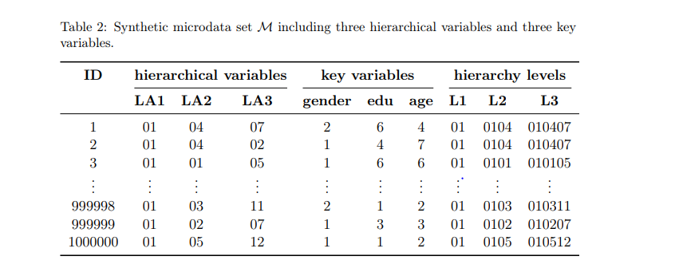

Masking the finest-level table. The finest-level table derived from the raw microdata in Table 2 is presented in Table 3, which comprises 25,272 rows. Due to the nested hierarchy, the number of valid geographic combinations is limited to 78, and the total row count reflects these units across all categories of gender, edu, and age. For brevity, Table 3 displays only the first and last three rows.

Table 3: Finest-level table from the microdata M. The raw frequency f is masked to ˜f SCA.

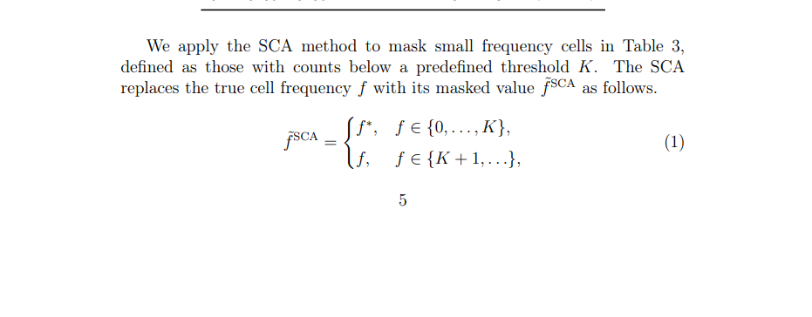
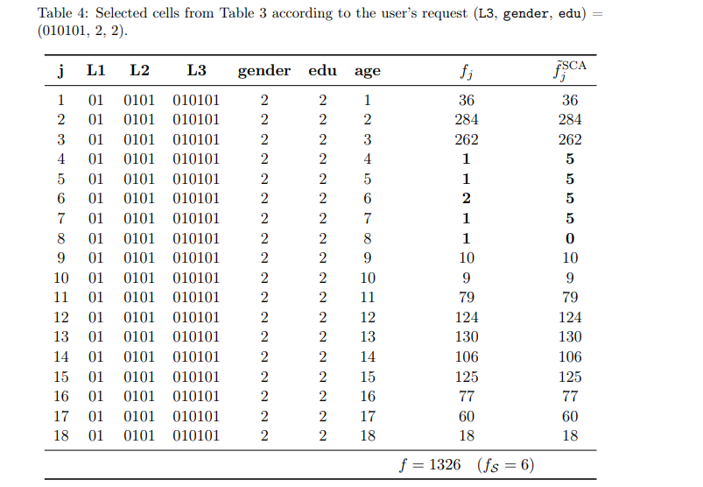

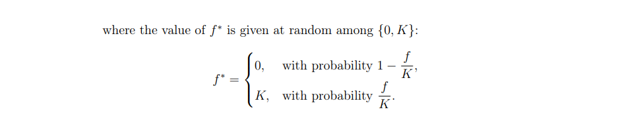

The SCA leaves a cell unchanged when its count is at least K. Since | ˜f SCA − f| ≤ K − 1, the SCA gaurantees bounded information loss and ensures Kanonymity, because all released cell counts are 0 or at least K. For the illustration in Table 3, we set K = 5.

Masking coaser-level tables. The subsequent phase involves masking aggregated, coarser-level tables while maintaining K-anonymity. To illustrate this procedure, consider a hypothetical user request for an aggregated count where (L3, gender, edu) = (010101, 2, 2). The corresponding 18 cells are extracted from Table 3 to form the subset presented in Table 4.

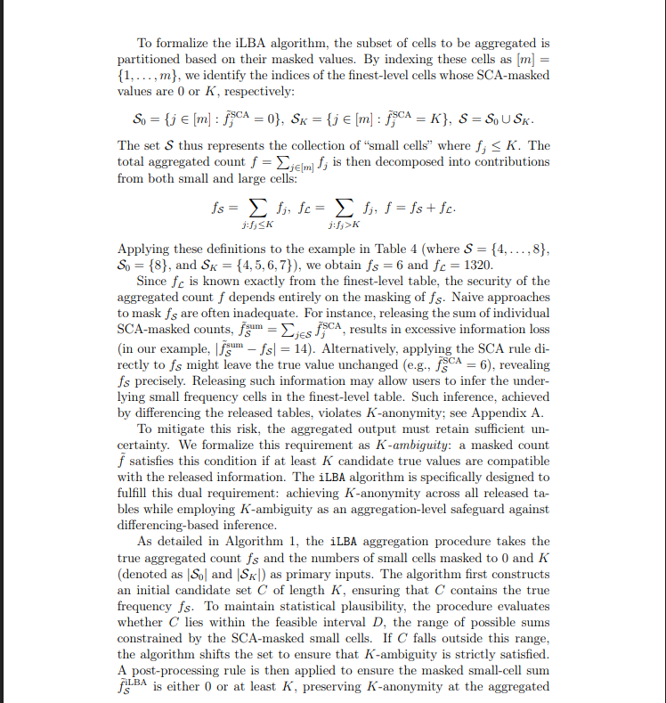

Algorithm 1 Loss-Bounded Aggregation (iLBA) Input: Small-cell index sets S0 and SK, true aggregated count fS, threshold K Output: Masked value ˜f iLBA S 1: if |S| = 0 or fS = 0 then 2: return ˜f iLBA S = 0 3: else if S = {j0} for some j0 then 4: return ˜f iLBA S = ˜f SCA j0 ∈ {0, K} 5: else 6: step 1: Compute initial candidate center: 7: ˜f (1) S ← fS − mod(fS − 1, K) + ⌊K/2⌋ 8: step 2: Define candidate set C: 9: C ← { ˜f (1) S − ⌊K/2⌋, . . . , ˜f (1) S − ⌊K/2⌋ + K − 1} 10: step 3: Adjust for feasible interval D (Shifting): 11: D ← n |SK|, |SK| + 1, . . . , K|SK| + (K − 1)|S0| o 12: if min(C) < min(D) then 13: ˜f (2) S ← ˜f (1) S + K 14: else if max(D) < max(C) then 15: ˜f (2) S ← ˜f (1) S − K 16: else 17: ˜f (2) S ← ˜f (1) S 18: end if 19: step 4: Apply post-processing rule: 20: ˜f (3) S ← ( K, if ˜f (2) S = 1 + ⌊K/2⌋ ˜f (2) S , otherwise 21: return ˜f iLBA S = ˜f (3) S 22: end if

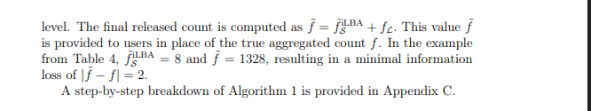

Guarantees of the ILBA algorithm:

For a fixed threshold K ≥ 3, the following properties hold:

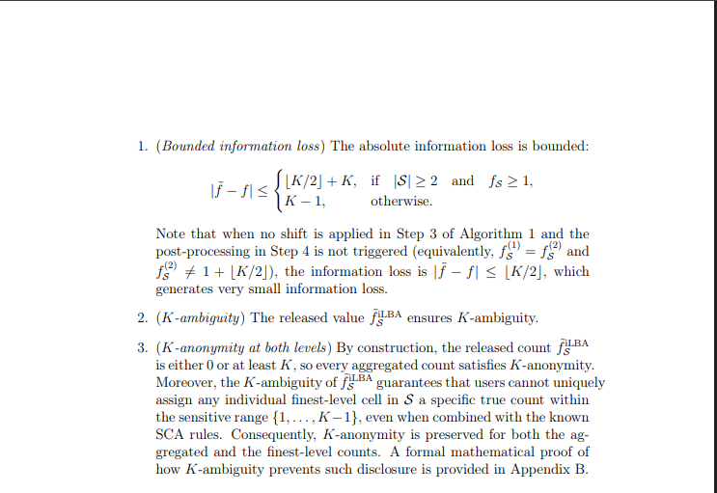

2 Software description

The iLBA R package is designed to enable users to obtain confidentially masked tables and frequencies from microdata. The source code of the package is available at https://github.com/SLTLab-SNU/iLBA_package. The package can be installed from the R console using the following commands.

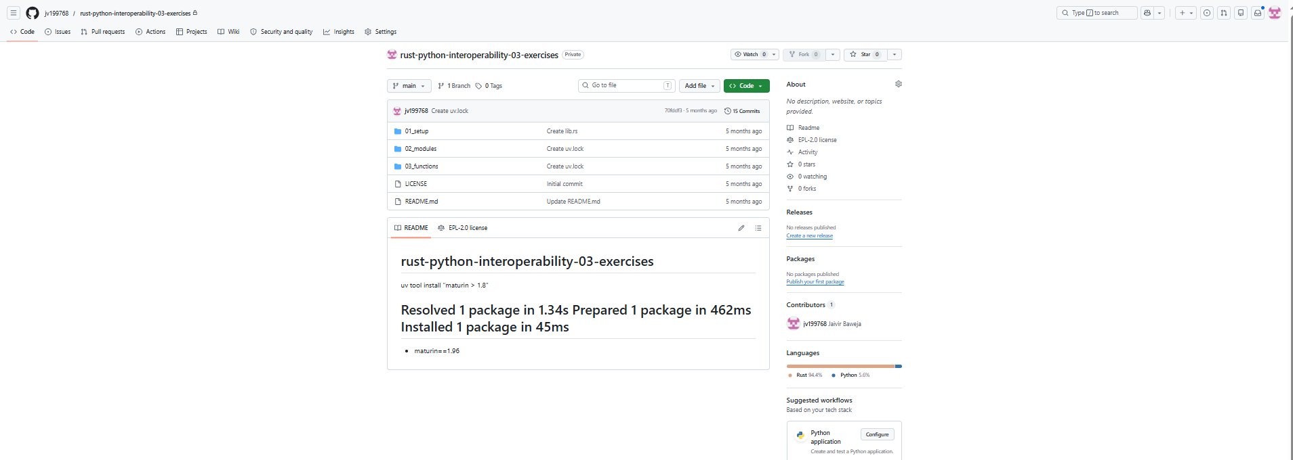

> install.packages(“remotes)
> remotes::install_github(“SLTLab-SNU/iLBA_package”)
> library (iLBA)

2.1 Software architecture

The iLBA R package is built in two layers: core masking functions and user-facing workflow functions. The core layer consists of apply_SCA() and apply_iLBA(), which implement the the privacy-preserving masking procedures defined in (1) and Algorithm 1, respectively. The user-facing layer provides high-level functions—save_full_tb(), save_agg_tb() and get_ agg_freq()—that manage the data pipeline from raw microdata to masked tabular outputs. Figure 1 illustrates this two-layer architecture and overall workflow of the package.

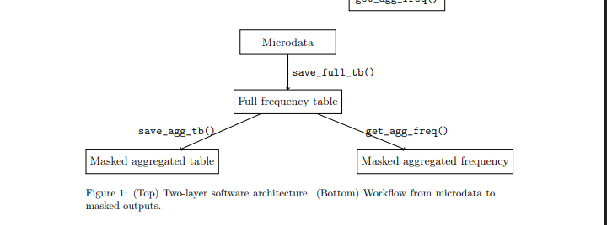

Given a microdata set, save_full_tb() first constructs the finest level table and applies apply_SCA() to each observed cell count. For computational efficiency, only observed combinations of variables are written in the finest level table, whereas zero count combinations are omitted. This design substantially reduces storage and computation, while leaving subsequent aggregation results unchanged because omitted combinations contribute zero to any aggregated count. The stored finest level table generated by save_full_tb() is then used in two ways. First, save_agg_tb() produces masked coarser level tables for user-selected hierarchical levels and key variables. Conceptually, at the requested hierarchical level, it groups the cells of the finest level table according to all combinations of the selected key variables, aggregates over lower level hierarchical units and omitted key variables, and then applies apply_iLBA() to each aggregated cell. Second, get_agg_freq() returns the masked frequency for a single target cell defined by a user-specified set of variable–attribute pairs. At the requested hierarchical level, it extracts the finest level cells corresponding to that target cell, aggregates their counts, and applies apply_iLBA() once to the aggregated count. Thus, while save_ agg_tb() applies apply_iLBA() repeatedly across all aggregated cells, get_ agg_freq() applies it only once for the requested cell. Because both functions rely on the same masking procedure, the value returned by get_agg_ freq() is consistent with the corresponding entry in the aggregated tables produced by save_agg_tb().

2.2 Software functionalities

The main user-facing functions of the package are save_full_tb(), save_ agg_tb(), and get_agg_freq(). save_full_tb( data, hkey, key = NULL, mask_thr = 5, hkey_rank = NULL, key_thr = 100, output_path = "full_tb.rds") The function save_full_tb() is the entry point for constructing the finest level frequency table from a microdata set. The user supplies a data.frame or data.table, the hierarchical variables (hkey), and optionally the key variables (key). If key is omitted, all non-hierarchical variables are used. The function requires at least one hierarchical variable. However, it can still be applied to datasets containing only key variables by designating one of the key variables as a hierarchical variable. The hierarchical variables should be specified either from coarser to finer levels or together with an optional argument hkey_rank. If hkey is not ordered from coarser to finer levels, hkey_rank must be provided as a vector of the same length indicating the hierarchical rank of each variable (e.g., province: 1, county: 2, town: 3). To avoid including quantitative variables, the function can exclude key variables whose number of categories exceeds a user-specified threshold key_thr, which defaults to 100. The function then applies apply_SCA() using the threshold mask_thr, which defaults to K = 5, and saves an RDS object in output_path, containing the finest level table, masked counts, and metadata such as variable names and category sets. The function also produces console output displaying a list of the hierarchical variables with their ranks, a list of the key variables, the masking threshold, and the output file path. This console output helps users specify inputs for subsequent functions. save_agg_tb( hkey_level, key, input_path = "full_tb.rds", output_tb_path = "agg_tb.csv", output_iL_path = "info_loss.csv") The function save_agg_tb() generates a masked coarser level table from a previously saved finest-level table. The user specifies the target hierarchical level (hkey_level), the key variables to select (key), and the path to the RDS object (input_path) produced by save_full_tb(). The hierarchical level must be provided as an integer and can be identified easily from the console output of save_full_tb(). For datasets with a single hierarchical variable, the level should be specified as 1. The function computes the true aggregated counts for all combinations of selected variables at the requested hierarchical level, applies apply_iLBA() to each aggregated cell, and writes the resulting masked table to a CSV file at the user-specified output_tb_path. In addition, a CSV file summarizing the differences between the true and masked counts is saved at output_iL_path. get_agg_freq( hkey_level, key, hkey_value, key_value, input_path = "full_tb.rds") The function save_agg_tb() returns a masked frequency for a userspecified cell. The user provides the hierarchical level (hkey_level) as an integer, the key variables to select (key), the corresponding hierarchical and key values (hkey_value and key_value) that define the target cell, and the path to the stored finest-level table (input_path). Internally, the function extracts the cells from the finest level table constituting the target cell. It then sums their counts, applies apply_iLBA() to the aggregated count, and returns the masked frequency. This function is useful when a user needs a protected value for a specific cell without generating the full aggregated table.

3. Non-illustrative examples

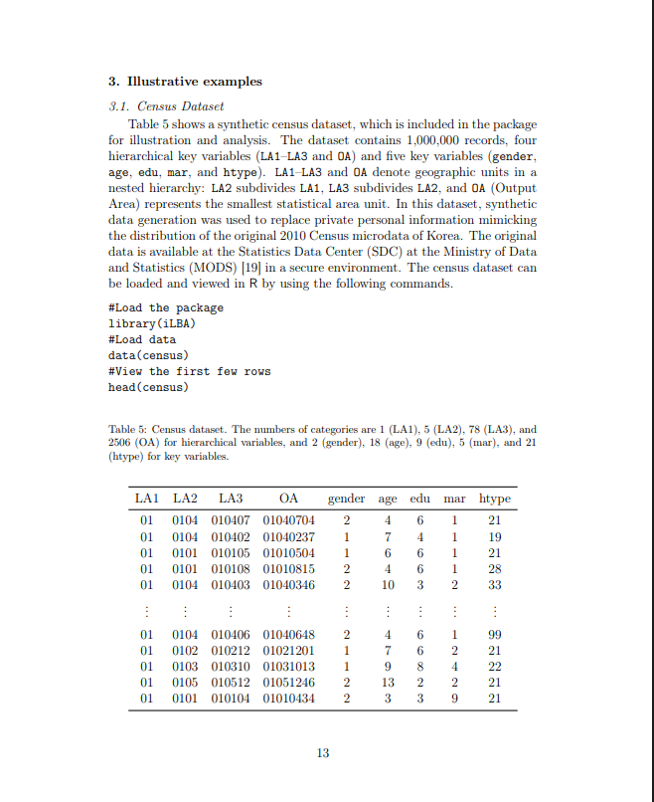
3.2 Construct the finest level table
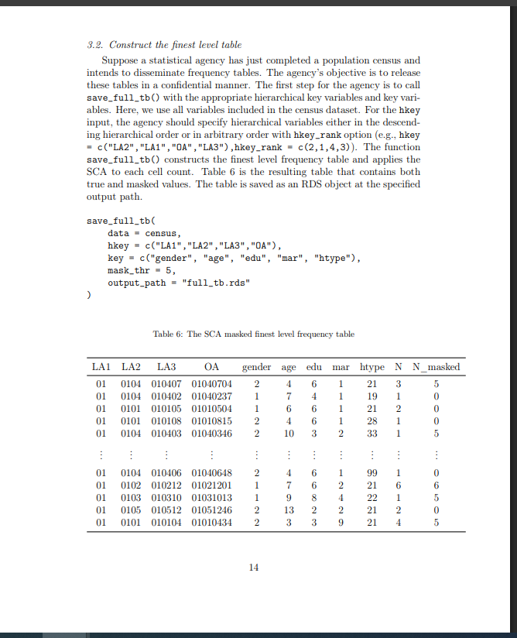

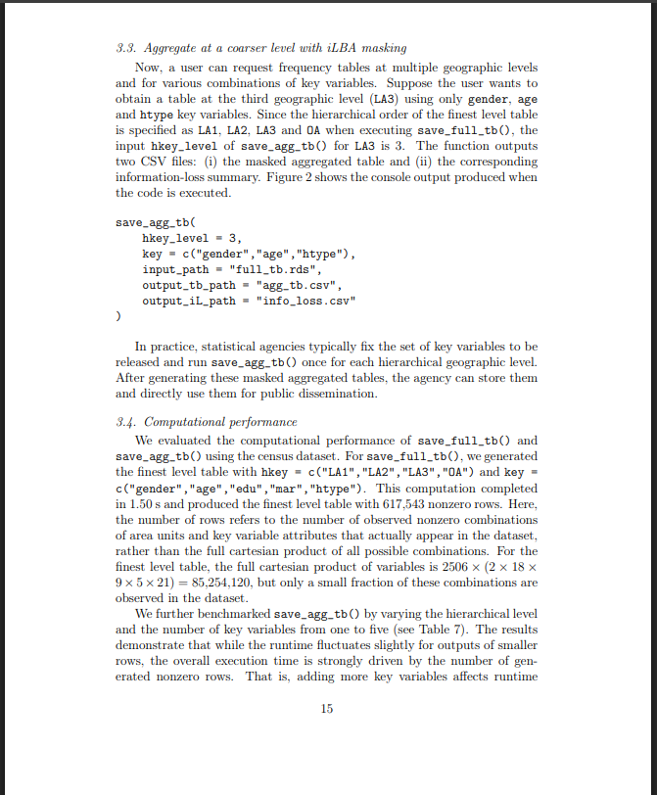

Figure 2: The coarser level table and its information loss summary

Primarily when it substantially increases the size of the table. Consequently, computations remain fast at higher hierarchical levels (i.e., closer to 1), but require more time at lower hierarchical levels (i.e., closer to 4) where significantly more combinations of variables must be processed.

Table 7: Runtime and output table size of save_agg_tb() by hierarchical level and number of key variables

hkey level | #keys | Keys used | Time (sec) | #rows
1 | 1 | Gender | 0.3234 | 2
1 | 2 | Gender, mar | 0.3210 | 10
1 | 3 | Gender, mar, edu | 0.3262 | 79
1 | 4 | Gender, mar, edu, age | 0.3209 | 777
1 | 5 | Gender, mar, edu, age, htype | 0.3261 | 5140
2 | 1 | Gender | 0.3234 | 10
2 | 2 | Gender, mar | 0.3210 | 50
2 | 3 | Gender, mar, edu | 0.3262 | 387
2 | 4 | Gender, mar, edu, age | 0.3209 | 3591
2 | 5 | Gender, mar, edu, age, htype | 0.3261 | 21474
3 | 1 | gender | 0.3234 | 156
3 | 2 | Gender, mar | 0.3210 | 780
3 | 3 | Gender, mar, edu | 0.3262 | 5627
3 | 4 | Gender, mar, edu, age | 0.3209 | 37070
3 | 5 | Gender, mar, edu, age, htype | 0.3261 | 145061
4 | 1 | gender | 0.3234 | 5012
4 | 2 | Gender, mar | 0.3210 | 24777
4 | 3 | Gender, mar, edu | 0.3262 | 116297
4 | 4 | Gender, mar, edu, age | 0.3209 | 370774
4 | 5 | Gender, mar, edu, age, htype | 0.3261 | 617543

Funding

This work was supported by the National Research Foundation of Korea (NRF) grants funded by the Korea government (MSIT) (RS-2024-00333399).

References

[1] Chipperfield J., Gow D., Loong B., The Australian Bureau of Statistics and releasing frequency tables via a remote server, Stat. J. IAOS 32 (2016) 53–64. https://doi.org/10.3233/SJI-160969. [2] Rinott Y., O’Keefe C.M., Shlomo N., Skinner C., Confidentiality and Differential Privacy in the Dissemination of Frequency Tables, Stat. Sci. 33 (3) (2018) 358–385. https://doi.org/10.1214/17-STS641. [3] Shlomo N., Antal L., Elliot M., Measuring Disclosure Risk and Data Utility for Flexible Table Generators, J. Off. Stat. 31 (2) (2015) 305– 324. https://doi.org/10.1515/jos-2015-0019.
[4] MSCI Inc., S&P Dow Jones Indices, The Global Industry Classification Standard (GICS®), https://www.msci.com/indexes/indexresources/gics (accessed 1 April 2026).
[5] Sweeney L., k-Anonymity: A model for protecting privacy, Int. J. Uncertain. Fuzziness Knowl.-Based Syst. 10 (5) (2002) 557–570. [6] Shlomo N., Statistical Disclosure Limitation: New Directions and Challenges, J. Privacy Confidentiality 8 (1) (2018). https://doi.org/10.29012/jpc.684. [7] Park M.-J., Kim H.J., Kwon S., Disseminating massive frequency tables by masking aggregated cell frequencies, J. Korean Stat. Soc. 53 (2) (2024) 328–348. https://doi.org/10.1007/s42952-023-00248-x. [8] Hundepool A., Domingo-Flores J., Franconi L., Giessing S., Schulte Nordholt E., Spicer K., De Wolf P.-P., Statistical Disclosure Control, Wiley, 2012. [9] Park M.-J., Bounded Small Cell Adjustments for Flexible Frequency Table Generators, in: Domingo-Ferrer J., Montes F. (Eds.), Privacy in Statistical Databases (PSD 2018), Lect. Notes Comput. Sci., vol. 11126, Springer, Cham, 2018. https://doi.org/10.1007/978-3-319-99771-1_2. [10] Hundepool A., Domingo-Ferrer J., Franconi L., Giessing S., Lenz R., Naylor J., Schulte Nordholt E., Seri G., De Wolf P.-P., Tent R., Młodak A., Gussenbauer J., Wilak K., Handbook on Statistical Disclosure Control, 2nd ed., Center of Excellence SDC, 2026. [11] Ministry of Data and Statistics, Republic of Korea, SGIS+: Statistical Geographic Information Service, https://sgis.mods.go.kr/jsp/english/index.jsp (accessed 1 April 2026). [12] de Wolf P.P., Hundepool A., Tau-ARGUS: Software for Statistical Disclosure Control of Tabular Data, Statistics Netherlands, 2003. [13] Statistics Netherlands, Tau-ARGUS 3.5 User’s Manual, 2009. Available at: https://research.cbs.nl/casc/tau.htm (accessed 1 April 2026). [14] Meindl B., Templ M., Alfons A., sdcTable: An R Package for Statistical Disclosure Control in Tabular Data, J. Stat. Softw. 76 (1) (2017) 1–31. https://doi.org/10.18637/jss.v076.i01.

[15] Meindl B., A Computational Framework to Protect Tabular Data – R Package sdcTable, in: Joint UNECE/Eurostat Work Session on Statistical Data Confidentiality, 2011. [16] Meindl B., CellKey: An R Package to Perturb Statistical Tables [software], Austrian J. Stat. (2025). [17] Thompson G., Broadfoot S., Elazar D., Methodology for the Automatic Confidentialisation of Statistical Outputs from Remote Servers at the Australian Bureau of Statistics, in: UNECE Work Session on Statistical Data Confidentiality, 2013. [18] Eurostat, Guidelines for Statistical Disclosure Control Methods Applied on Geo-Referenced Data, European Commission, 2025. [19] Ministry of Data and Statistics, Republic of Korea, Statistics Data Center, https://data.kostat.go.kr (accessed 1 April 2026 and 1 April 2012). (accessed 1 April 2012)

Appendix A. Pitfalls of naive application of the SCA method

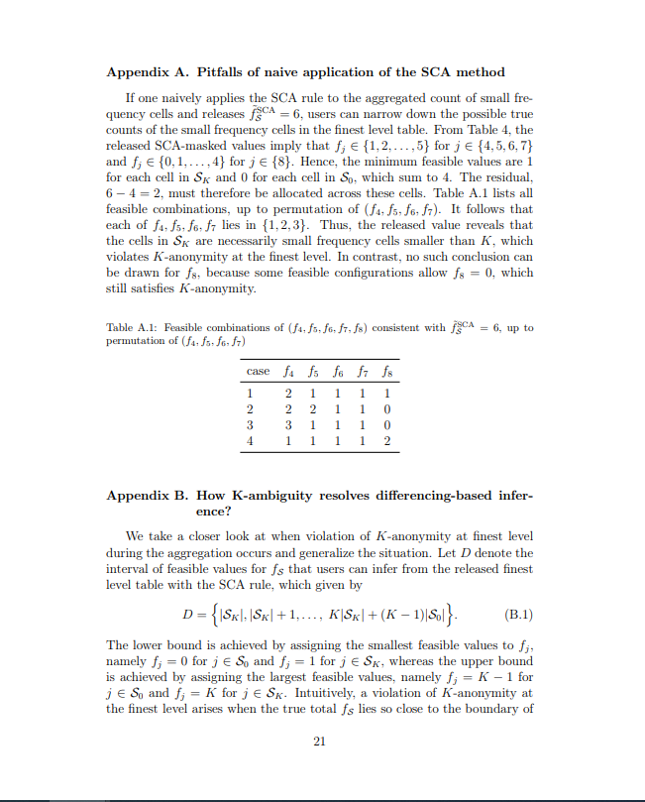
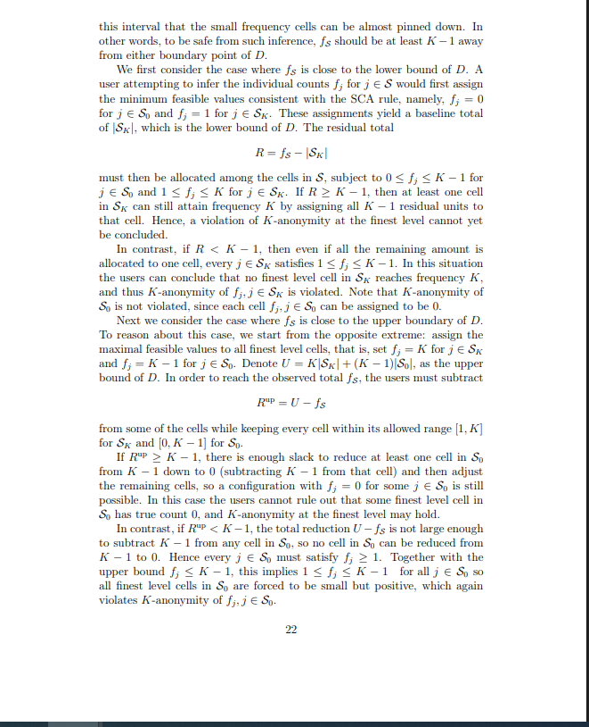

To prevent such violations of K-anonymity when fS lies close to the boundary of D, the released information must leave sufficiently many feasible values for fS inside D. By endowing K-ambiguity to fS, the users can no longer almost uniquely determine any finest level count as a small positive value.

However, some of these candidates may partly lie outside the feasible interval D defined in (B.1). In such a case, only the portion C ∩ D is inside D, and it may contain fewer than K feasible candidates, which breaks Kanonymity at the finest level. To prevent this, we adjust ˜f (1) S so that every candidate in interval C is entirely contained in D. We can observe that, given K ≥ 2, we have |C| = K ≤ |D|, so the length of D is always at least as large as that of C. Hence C can never fully cover D. Intuitively, when the range of C is not fully contained in the range of D, the range of C is partly lie outside the range of D on at most one side. If we denote the lower and upper boundaries of an interval I by min(I) and max(I), respectively, then the range of C is not fully contained in the range of D precisely when

min(C) < min(D) or max(D) < max(C) (C.5)

